WEB DEVELOPMENT
PROJECT REPORT
FITZONE FITNESS CENTER
A simple multi-page website developed using HTML and CSS
Submitted by: ______________________________
Roll Number: _______________________________
Department: Computer Science and Engineering
Academic Year: 2026–2027

CONTENTS
1. Introduction
2. Aim
3. Objectives
4. HTML Concepts
5. CSS Concepts
6. Procedure
7. Source Code
8. Output Screenshots
9. Conclusion

1. Introduction
FitZone Fitness Center is a basic multi-page website created to present the services and facilities of a gym. The website provides information about workout programs, trainers, membership plans, gym facilities, class schedules and registration. It uses HTML to organize the webpage content and CSS to style the pages.
The project contains a home page and separate pages for programs, trainers, membership, facilities and registration. A common CSS file is linked to the HTML pages to maintain a consistent design.

2. Aim
To design and develop a simple, user-friendly gym website named FitZone Fitness Center using basic HTML and CSS concepts.

3. Objectives
- To create a home page that introduces FitZone Fitness Center.
- To display different workout programs such as weight training, cardio, yoga, Zumba and strength training.
- To present trainer details and their specializations.
- To show Basic, Standard and Premium membership plans.
- To describe the available gym facilities.
- To display a weekly class schedule and contact information.
- To create a registration form for collecting visitor details and preferences.
- To practise linking multiple HTML pages with one external CSS file.

4. HTML Concepts
HTML document structure: The pages use the basic HTML structure with <!DOCTYPE html>, <html>, <head> and <body> elements.
Head and title: The <head> section contains page information, the title and the link to the external stylesheet.
Headings and paragraphs: Heading tags such as <h1>, <h2> and <h3>, along with <p>, organize the page text.
Links: The <a> tag connects the pages, such as Home, Programs, Trainers, Membership, Facilities and Registration.
Images: The <img> tag displays gym and workout images on relevant pages.
Lists and tables: The home page uses a table to display the weekly class schedule, while membership details are arranged in plan sections and a comparison table.
Forms and input elements: The registration page uses labels, text and number inputs, an email field, a telephone field, selection lists and a submit button.
Div containers: The <div> element groups related content into sections such as the navbar, home area, cards, plans and contact area.

5. CSS Concepts
Selectors: Element selectors and class selectors such as body, .navbar, .home, .section, .card, .plan and .footer apply styles to page elements.
Colors and backgrounds: Background and text colors create contrast, with dark navigation areas, red highlights and light page backgrounds.
Text styling: Font family, font size, text alignment and text color control the appearance of headings and other text.
Spacing: Margin and padding provide space around page sections, cards, tables and form elements.
Borders and rounded corners: Borders and border-radius are used on cards, tables, buttons and forms.
Hover effects: The :hover pseudo-class changes link, card and button appearance when a pointer is placed over them.
Layout: Inline-block display, widths and vertical alignment arrange cards and membership plans.
Form styling: CSS styles labels, inputs, select boxes and the registration submit button.

6. Procedure
- Create a project folder and save all HTML pages and the CSS file in the same folder.
- Create index(2).html as the home page and add the website heading, navigation links, welcome message, class schedule and contact details.
- Create programs.html to display the workout programs using headings, images and description cards.
- Create trainer.html to display trainer names, photographs and specializations.
- Create member.html to show membership plans, prices, durations and a comparison table.
- Create facilities.html to describe the gym facilities.
- Create register.html and add a form with fields for name, age, email, phone number, preferred workout and membership plan.
- Create style.css and define common styles for the body, navigation bar, sections, cards, tables, forms, buttons and footer.
- Link the external stylesheet to each HTML page using the <link rel="stylesheet" href="style.css"> element.
- Open the home page in a web browser and navigate through the available pages to check the website.

7. Source Code
The following source listings are reproduced from the uploaded project files. Each HTML page links to the shared style.css file.

Home Page — index(2).html
<!DOCTYPE html>
<html>
<head>
<title>FitZone Fitness Center</title>
<link rel="stylesheet" href="style.css">
</head>
<body>
<div class="navbar">
<h2>FitZone Fitness Center</h2>
<a href="#home">Home</a>
<a href="programs.html">Programs</a>
<a href="trainer.html">Trainers</a>
<a href="member.html">Membership</a>
<a href="facilities.html">Facilities</a>
<a href="#schedule">Schedule</a>
<a href="register.html">Registration</a>
</div>
<div class="home">
<h1>Welcome to FitZone Fitness Center</h1>
<h2>BUILD YOUR BODY, BUILD YOUR CONFIDENCE!</h2>
<p>Your fitness journey starts here. Stay strong and healthy!</p>
<img src="https://images.unsplash.com/photo-1534438327276-14e5300c3a48?auto=format&fit=crop&w=1000&q=80"
alt="Modern gym equipment">
<p>Join FitZone and work towards a healthier lifestyle.</p>
<a href="register.html" class="button">Join Our Gym</a>
</div>
<div class="section">
<h1>Class Schedule</h1>
<table>
<tr>
<th>Day</th>
<th>Class</th>
<th>Time</th>
<th>Trainer</th>
</tr>
<tr>
<td>Monday</td>
<td>Weight Training</td>
<td>7:00 AM</td>
<td>Rahul</td>
</tr>
<tr>
<td>Tuesday</td>
<td>Yoga</td>
<td>8:00 AM</td>
<td>Priya</td>
</tr>
<tr>
<td>Wednesday</td>
<td>Cardio</td>
<td>6:00 PM</td>
<td>Arjun</td>
</tr>
<tr>
<td>Thursday</td>
<td>Zumba</td>
<td>5:00 PM</td>
<td>Priya</td>
</tr>
<tr>
<td>Friday</td>
<td>Strength Training</td>
<td>7:00 AM</td>
<td>Rahul</td>
</tr>
</table>
</div>
<!-- Contact Section -->
<div class="contact">
<h1>Contact Us</h1>
<p><b>Address:</b> Main Road, Vijayawada, Andhra Pradesh</p>
<p><b>Phone:</b> +91 7989865426</p>
<p><b>Email:</b> fitzone544@example.com</p>
<p><b>Opening Hours:</b> Monday to Saturday, 6 AM – 9 PM</p>
</div>
<!-- Footer -->
<div class="footer">
<p>©️ 2026 FitZone Fitness Center. All Rights Reserved.</p>
<p>Stay Fit. Stay Strong.</p>
</div>
</body>
</html>

Workout Programs — programs.html
<!DOCTYPE html>
<html>
<head>
<title>programs</title>
<link rel="stylesheet" href="style.css">
</head>
<body>
<div class="navbar">
<h2>FitZone Fitness Center</h2>
<a href="#home">Home</a>
<a href="programs.html">Programs</a>
<a href="trainer.html">Trainers</a>
<a href="member.html">Membership</a>
<a href="facilities.html">Facilities</a>
<a href="#schedule">Schedule</a>
<a href="register.html">Registration</a>
</div>
<div class="section" id="programs">
<h1>Our Workout Programs</h1>
<div class="card">
<img src="https://images.unsplash.com/photo-1583454110551-21f2fa2afe61?auto=format&fit=crop&w=500&q=80"
alt="Weight training">
<h3>Weight Training</h3>
<p>Build strength and improve muscle fitness.</p>
</div>
<div class="card">
<img src="https://images.unsplash.com/photo-1538805060514-97d9cc17730c?auto=format&fit=crop&w=500&q=80"
alt="Cardio workout">
<h3>Cardio</h3>
<p>Improve stamina and heart health.</p>
</div>
<div class="card">
<img src="https://images.unsplash.com/photo-1544367567-0f2fcb009e0b?auto=format&fit=crop&w=500&q=80"
alt="Yoga class">
<h3>Yoga</h3>
<p>Relax your mind and improve flexibility.</p>
</div>
<div class="card">
<img src="https://images.unsplash.com/photo-1518611012118-696072aa579a?auto=format&fit=crop&w=500&q=80"
alt="Fitness class">
<h3>Zumba</h3>
<p>Enjoy energetic dance-based workouts.</p>
</div>
<div class="card">
<img src="https://images.unsplash.com/photo-1534438327276-14e5300c3a48?auto=format&fit=crop&w=500&q=80"
alt="Strength training">
<h3>Strength Training</h3>
<p>Improve strength with guided exercises.</p>
</div>
</div>
</body>
</html>

Trainers — trainer.html
<!DOCTYPE html>
<html>
<head>
<title> trainer</title>
<link rel="stylesheet" href="style.css">
</head>
<body>
<div class="navbar">
<h2>FitZone Fitness Center</h2>
<a href="#home">Home</a>
<a href="programs.html">Programs</a>
<a href="trainer.html">Trainers</a>
<a href="member.html">Membership</a>
<a href="facilities.html">Facilities</a>
<a href="#schedule">Schedule</a>
<a href="register.html">Registration</a>
</div>
<div class="section" id="trainers">
<h1>Meet Our Trainers</h1>
<div class="card">
<img src="https://images.unsplash.com/photo-1567013127542-490d757e51fc?auto=format&fit=crop&w=500&q=80"
alt="Fitness trainer">
<h3>Sujan Naidu</h3>
<p>Specialization: Weight Training</p>
<p>Helps members learn safe exercise techniques.</p>
</div>
<div class="card">
<img src="https://images.unsplash.com/photo-1571019613454-1cb2f99b2d8b?auto=format&fit=crop&w=500&q=80"
alt="Fitness coach">
<h3>Aadhya Sharma</h3>
<p>Specialization: Yoga and Fitness</p>
<p>Guides members through fitness activities.</p>
</div>
<div class="card">
<img src="https://images.unsplash.com/photo-1583454110551-21f2fa2afe61?auto=format&fit=crop&w=500&q=80"
alt="Strength coach">
<h3>Rudra</h3>
<p>Specialization: Strength Training</p>
<p>Helps members practise strength exercises.</p>
</div>
</div>
</body>
</html>

Membership Plans — member.html
<!DOCTYPE html>
<html>
<head>
<title>Membership Plans - FitZone</title>
<link rel="stylesheet" href="style.css">
</head>
<body>
<h2>FitZone Fitness Center</h2>
<div class="navbar">
<a href="#home">Home</a>
<a href="programs.html">Programs</a>
<a href="trainer.html">Trainers</a>
<a href="member.html">Membership</a>
<a href="facilities.html">Facilities</a>
<a href="#schedule">Schedule</a>
<a href="register.html">Registration</a>
</div>
<div class="home">
<h1>Our Membership Plans</h1>
<p>Choose the right plan for your fitness journey!</p>
</div>
<div class="section">
<div class="plan">
<h2>Basic Plan</h2>
<h1>₹999</h1>
<p>Duration: 1 Month</p>
<hr>
<p>✔ Gym Equipment</p>
<p>✔ General Workout Area</p>
<p>✔ Changing Rooms</p>
<p>✘ Personal Trainer</p>
<a href="register.html" class="button">Join Now</a>
</div>
<div class="plan">
<h2>Standard Plan</h2>
<h1>₹2,499</h1>
<p>Duration: 3 Months</p>
<hr>
<p>✔ Gym Equipment</p>
<p>✔ Group Fitness Classes</p>
<p>✔ Changing Rooms</p>
<p>✔ Trainer Guidance</p>
<a href="register.html" class="button">Join Now</a>
</div>
<div class="plan">
<h2>Premium Plan</h2>
<h1>₹4,999</h1>
<p>Duration: 6 Months</p>
<hr>
<p>✔ All Gym Facilities</p>
<p>✔ Group Fitness Classes</p>
<p>✔ Personal Trainer Guidance</p>
<p>✔ Special Workout Support</p>
<a href="register.html" class="button">Join Now</a>
</div>
</div>
<div class="section">
<h1>Compare Our Plans</h1>
<table>
<tr>
<th>Facilities</th>
<th>Basic</th>
<th>Standard</th>
<th>Premium</th>
</tr>
<tr>
<td>Gym Equipment</td>
<td>Yes</td>
<td>Yes</td>
<td>Yes</td>
</tr>
<tr>
<td>Group Classes</td>
<td>No</td>
<td>Yes</td>
<td>Yes</td>
</tr>
<tr>
<td>Trainer Guidance</td>
<td>No</td>
<td>Yes</td>
<td>Yes</td>
</tr>
<tr>
<td>Duration</td>
<td>1 Month</td>
<td>3 Months</td>
<td>6 Months</td>
</tr>
</table>
</div>
</body>
</html>

Facilities — facilities.html
<!DOCTYPE html>
<html>
<head>
<title>facilities</title>
<link rel="stylesheet" href="style.css">
</head>
<body>
div class="navbar">
<h2>FitZone Fitness Center</h2>
<a href="#home">Home</a>
<a href="programs.html">Programs</a>
<a href="trainer.html">Trainers</a>
<a href="member.html">Membership</a>
<a href="facilities.html">Facilities</a>
<a href="#schedule">Schedule</a>
<a href="register.html">Registration</a>
</div>
<div class="section" id="facilities">
<h1>Our Facilities</h1>
<div class="card">
<h3>Modern Equipment</h3>
<p>Equipment for a variety of workouts.</p>
</div>
<div class="card">
<h3>Changing Rooms</h3>
<p>Clean and comfortable changing areas.</p>
</div>
<div class="card">
<h3>Personal Training</h3>
<p>Guidance from fitness trainers.</p>
</div>
<div class="card">
<h3>Workout Area</h3>
<p>Space for stretching and exercises.</p>
</div>
</div>
</body>
</html>

Registration — register.html
<!DOCTYPE html>
<html>
<head>
<title>register</title>
<link rel="stylesheet" href="style.css">
</head>
<body>
<div class="section" id="registration">
div class="navbar">
<h2>FitZone Fitness Center</h2>
<a href="#home">Home</a>
<a href="programs.html">Programs</a>
<a href="trainer.html">Trainers</a>
<a href="member.html">Membership</a>
<a href="facilities.html">Facilities</a>
<a href="#schedule">Schedule</a>
<a href="register.html">Registration</a>
</div>
<h1>Gym Registration Form</h1>
<p>Fill in your details to register your interest.</p>
<form action="#" method="get">
<label>Full Name:</label>
<input type="text" name="name" required>
<label>Age:</label>
<input type="number" name="age" min="13" max="100" required>
<label>Email:</label>
<input type="email" name="email" required>
<label>Phone Number:</label>
<input type="tel" name="phone" required>
<label>Preferred Workout:</label>
<select name="workout">
<option>Weight Training</option>
<option>Cardio</option>
<option>Yoga</option>
<option>Zumba</option>
<option>Strength Training</option>
</select>
<label>Membership Plan:</label>
<select name="membership">
<option>Basic</option>
<option>Standard</option>
<option>Premium</option>
</select>
<input type="submit" value="Submit Registration">
</form>
</div>
</body>
</html>

Common Stylesheet — style.css
body {
margin: 0;
font-family: Arial, sans-serif;
background-color: #eeeeee;
color: #222222;
}
.navbar {
background-color: #222222;
text-align: center;
padding: 15px;
}
.navbar h2 {
color: red;
font-size: 28px;
}
.navbar a {
color: white;
text-decoration: none;
margin: 8px;
font-size: 15px;
}
.navbar a:hover {
color: red;
}
.home {
background-color: #333333;
color: white;
text-align: center;
padding: 30px;
}
.home h1 {
color: red;
font-size: 35px;
}
.home h2 {
font-size: 22px;
}
.home img {
width: 80%;
max-width: 800px;
height: 300px;
border-radius: 10px;
}
.button {
display: inline-block;
background-color: red;
color: white;
padding: 12px 25px;
text-decoration: none;
border-radius: 5px;
}
.button:hover {
background-color: #990000;
transition: 0.3s;
}
.section {
text-align: center;
padding: 30px 10px;
}
.section h1 {
color: #cc0000;
font-size: 30px;
}
.card {
display: inline-block;
background-color: white;
width: 250px;
margin: 12px;
padding: 12px;
border: 1px solid #cccccc;
border-radius: 8px;
vertical-align: top;
}
.card img {
width: 100%;
height: 180px;
border-radius: 5px;
}
.card h3 {
color: #cc0000;
}
.card:hover {
background-color: #ffe6e6;
transition: 0.3s;
}
table {
width: 90%;
margin: 20px auto;
border-collapse: collapse;
background-color: white;
}
th {
background-color: #cc0000;
color: white;
}
th, td {
border: 1px solid #999999;
padding: 12px;
text-align: center;
}
form {
background-color: white;
width: 80%;
max-width: 450px;
margin: 20px auto;
padding: 20px;
border: 1px solid #cccccc;
border-radius: 8px;
text-align: left;
}
label {
display: block;
margin-top: 12px;
font-weight: bold;
}
input, select {
width: 95%;
padding: 10px;
margin-top: 5px;
border: 1px solid #999999;
border-radius: 4px;
}
input[type="submit"] {
width: 100%;
background-color: red;
color: white;
font-weight: bold;
margin-top: 20px;
cursor: pointer;
}
input[type="submit"]:hover {
background-color: #990000;
}
.contact {
background-color: #dddddd;
text-align: center;
padding: 30px;
}
.contact h1 {
color: #cc0000;
}
.footer {
background-color: #222222;
color: white;
text-align: center;
padding: 15px;
}
body {
margin: 0;
font-family: Arial, sans-serif;
background-color: #eeeeee;
color: #222222;
}
.navbar {
background-color: #222222;
text-align: center;
padding: 15px;
}
.navbar h2 {
color: red;
}
.navbar a {
color: white;
text-decoration: none;
margin: 8px;
}
.home {
background-color: #333333;
color: white;
text-align: center;
padding: 30px;
}
.home h1 {
color: red;
}
.section {
text-align: center;
padding: 30px 10px;
}
.plan {
display: inline-block;
background-color: white;
width: 250px;
margin: 12px;
padding: 20px;
border: 1px solid #cccccc;
border-radius: 8px;
vertical-align: top;
}
.plan h2 {
color: #cc0000;
}
.plan h1 {
color: #222222;
font-size: 30px;
}
.plan p {
font-size: 15px;
}
.button {
display: inline-block;
background-color: red;
color: white;
padding: 10px 20px;
margin-top: 10px;
text-decoration: none;
border-radius: 5px;
}
.button:hover {
background-color: #990000;
}
table {
width: 90%;
margin: 20px auto;
border-collapse: collapse;
background-color: white;
}
th {
background-color: #cc0000;
color: white;
}
th, td {
border: 1px solid #999999;
padding: 12px;
text-align: center;
}

8. Output Screenshots
The following screenshots show the main pages of the FitZone website as rendered for this report. The screenshots use the supplied HTML and CSS. A small missing opening angle bracket in the navigation markup of facilities.html and register.html was corrected only in the temporary rendering copies so the intended page layout could be previewed; the source listings above remain unchanged from the uploaded files.

Home Page
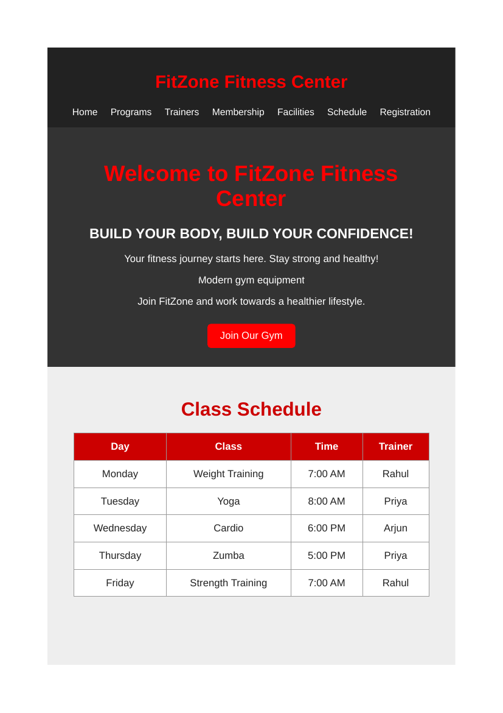
Home Page — browser output

Workout Programs
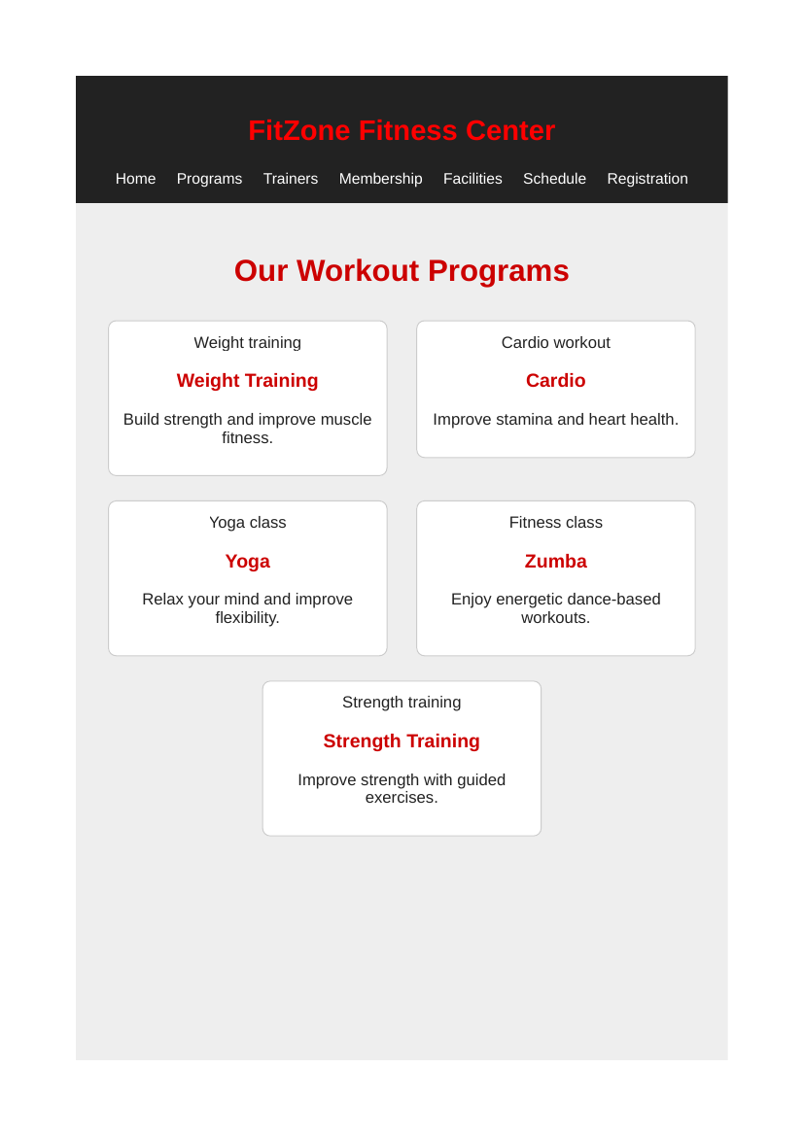
Workout Programs — browser output

Trainers
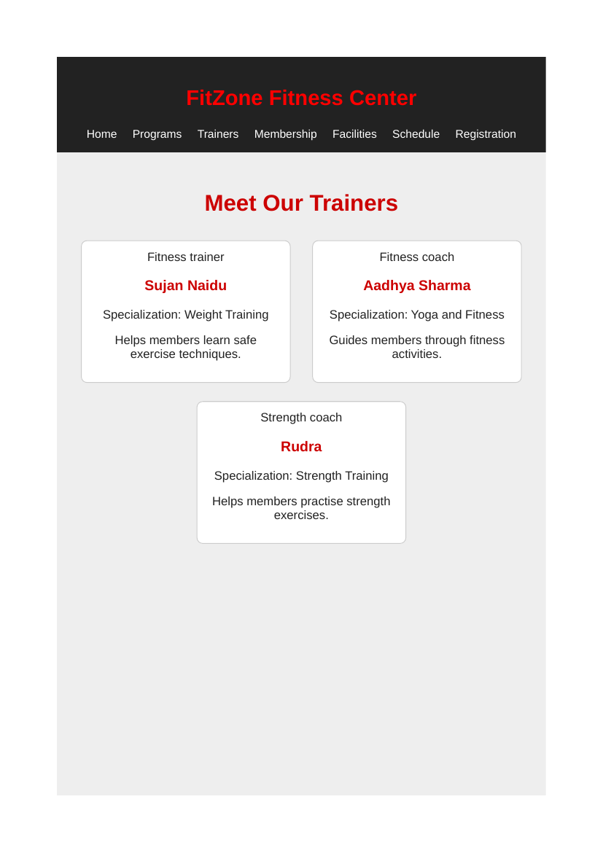
Trainers — browser output

Membership Plans
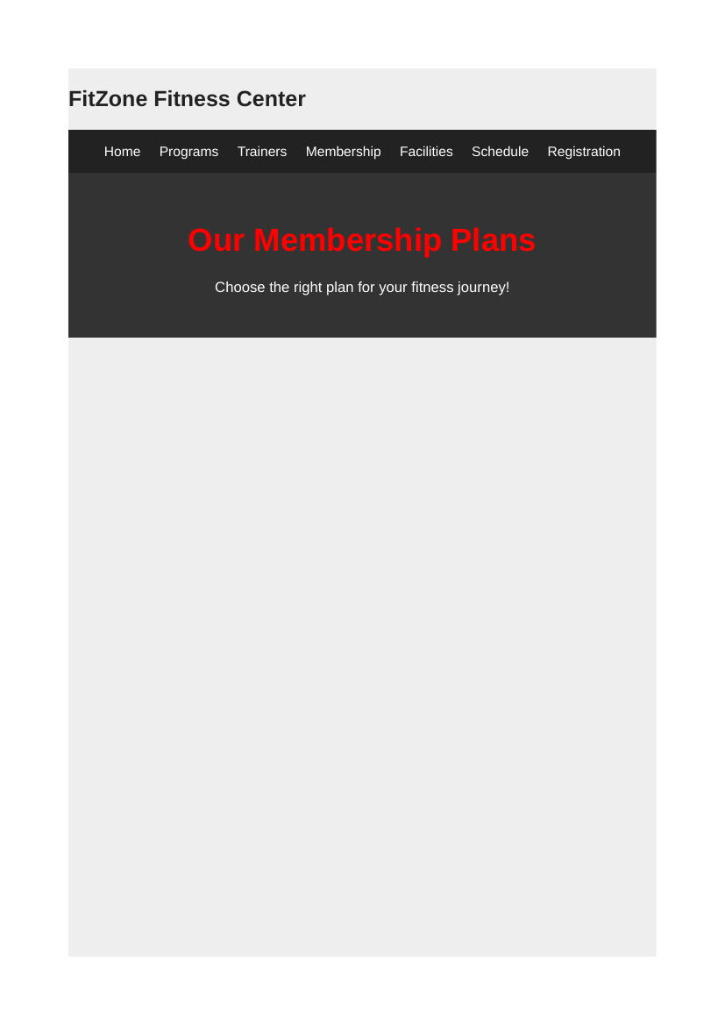
Membership Plans — browser output

Facilities
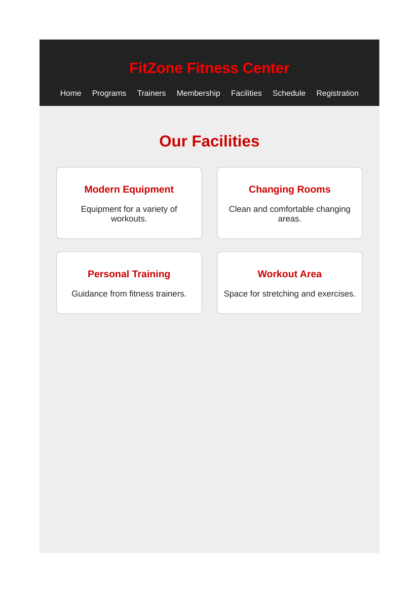
Facilities — browser output

Registration Form
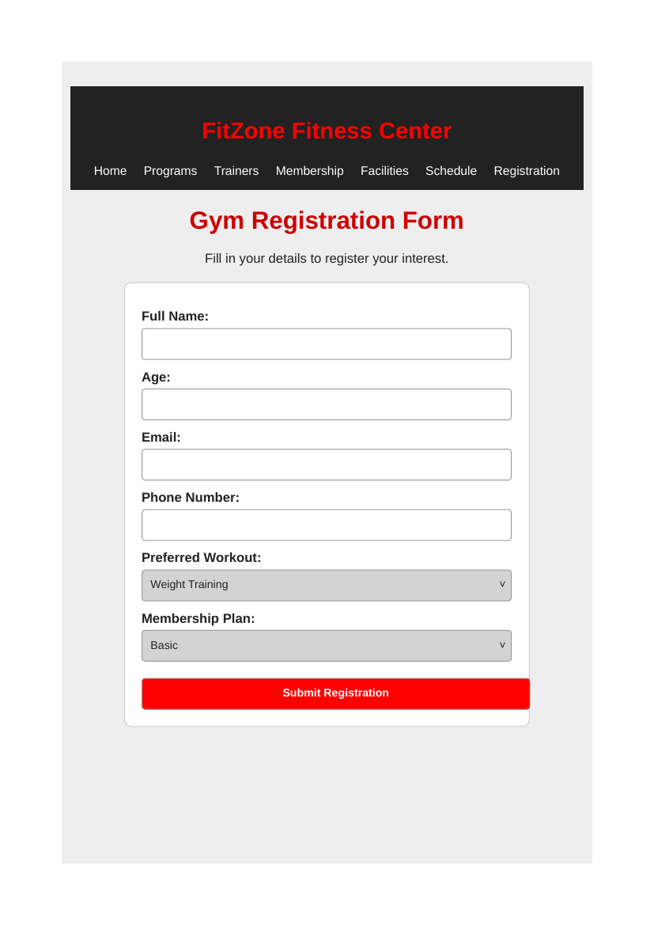
Registration Form — browser output

9. Conclusion
The FitZone Fitness Center website demonstrates the use of basic HTML and CSS to build a simple multi-page website. It includes information about workout programs, trainers, membership plans, facilities, class schedules and registration. The project provides practical experience in creating HTML pages, linking pages through navigation, using forms and tables, and applying a common stylesheet. It can be extended in the future with JavaScript validation, responsive design improvements and a working form-submission system.

